# **Template Email to Student Life for Communications Support**

Hello Student Life team,

On behalf of the _____ Club, I wanted to request student communications for our upcoming _____ event on __(date)__. Here is more information:

* Accessibility: Approved for accessibility by __(name)__ (*if graphic included- otherwise N/A*)
* Actions requested:
  + Coastline mobile app push notification
  + Student Services Newsletter: weekly update to Student Services departments such as EOPS, Student Life, Admissions & Records, etc.
  + Message to National Society of Leadership & Success (NSLS) members

I have included more details about the event below:

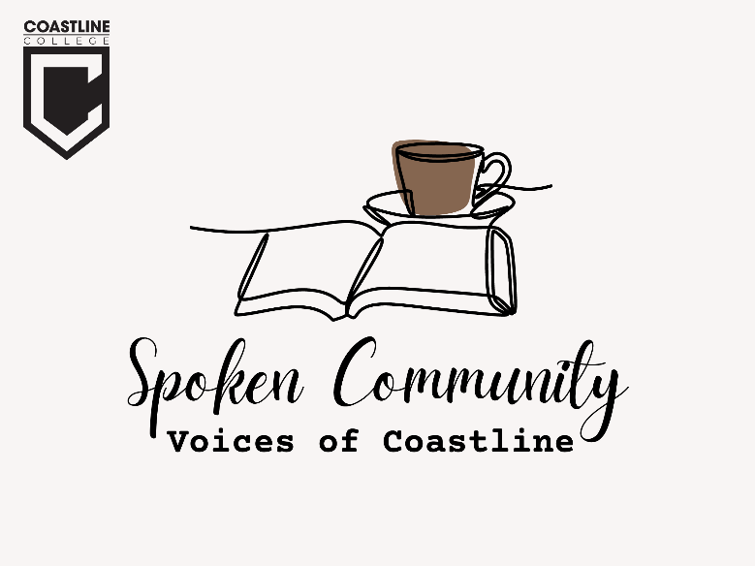

**Spoken Community: Voices of Coastline**

The [National English Honor Society](https://nam10.safelinks.protection.outlook.com/?url=https%3A%2F%2Fwww.coastline.edu%2Fstudent-life%2Fclubs-and-organizations%2Fnational-english-honor-society.php&data=05%7C01%7Cacarlock%40coastline.edu%7C75368219ff4941d34ba508db2bc83684%7Cee57f5551d704a8b8edac0f4071a4458%7C0%7C0%7C638151911145991594%7CUnknown%7CTWFpbGZsb3d8eyJWIjoiMC4wLjAwMDAiLCJQIjoiV2luMzIiLCJBTiI6Ik1haWwiLCJXVCI6Mn0%3D%7C3000%7C%7C%7C&sdata=Nf8%2B5B7GX88ave08wKPelLsGmuVNHiAFwxsmB9SFJS0%3D&reserved=0), [Associated Student Government (ASG)](https://nam10.safelinks.protection.outlook.com/?url=https%3A%2F%2Fwww.coastline.edu%2Fstudent-life%2Fassociated-student-government.php&data=05%7C01%7Cacarlock%40coastline.edu%7C75368219ff4941d34ba508db2bc83684%7Cee57f5551d704a8b8edac0f4071a4458%7C0%7C0%7C638151911145991594%7CUnknown%7CTWFpbGZsb3d8eyJWIjoiMC4wLjAwMDAiLCJQIjoiV2luMzIiLCJBTiI6Ik1haWwiLCJXVCI6Mn0%3D%7C3000%7C%7C%7C&sdata=so%2Br1che3Gd3BjtacUyOYX9TV7jDZ%2FWAQLQwT4W4wXc%3D&reserved=0), and [English & Humanities Department](https://nam10.safelinks.protection.outlook.com/?url=https%3A%2F%2Fwww.coastline.edu%2Facademics%2Facademic-departments%2Fenglish-and-humanities.php%23%3A~%3Atext%3DCoastline%2520has%2520a%2520wide%2520variety%2Cstudy%2520of%2520arts%2520and%2520civilizations.&data=05%7C01%7Cacarlock%40coastline.edu%7C75368219ff4941d34ba508db2bc83684%7Cee57f5551d704a8b8edac0f4071a4458%7C0%7C0%7C638151911145991594%7CUnknown%7CTWFpbGZsb3d8eyJWIjoiMC4wLjAwMDAiLCJQIjoiV2luMzIiLCJBTiI6Ik1haWwiLCJXVCI6Mn0%3D%7C3000%7C%7C%7C&sdata=6yYzPV5gsNNp%2BwrCGYadRx6udF%2FBDo6lzODcW0ZSKyM%3D&reserved=0) invite you to experience local art and connect with students and faculty through poetic prose. Coastline poets and lovers of the written word, we welcome you to share your own work and appreciate poems by other Coastline community members at a poetry reading hosted at the [Art Gallery](https://nam10.safelinks.protection.outlook.com/?url=https%3A%2F%2Fwww.coastline.edu%2Flocations%2Fnewport-beach-campus%2Fart-gallery.php&data=05%7C01%7Cacarlock%40coastline.edu%7C75368219ff4941d34ba508db2bc83684%7Cee57f5551d704a8b8edac0f4071a4458%7C0%7C0%7C638151911145991594%7CUnknown%7CTWFpbGZsb3d8eyJWIjoiMC4wLjAwMDAiLCJQIjoiV2luMzIiLCJBTiI6Ik1haWwiLCJXVCI6Mn0%3D%7C3000%7C%7C%7C&sdata=l7S48q8mX%2FL1N%2BuDJqGF4LL3XnNT9LQ1jwiPTnajT9I%3D&reserved=0) on April 28th from 4-5p.m. prior to the Art Gallery Reception from 5-7p.m.

Date: Friday, April 28th

Time: Poetry Reading 4-5p.m. prior to Art Gallery Reception 5-7p.m.

Location: Newport Beach Campus Art Gallery

1515 Monrovia Ave., Newport Beach, CA 92663

[Sign up as a poetry reader](https://nam10.safelinks.protection.outlook.com/?url=https%3A%2F%2Fdocs.google.com%2Fforms%2Fd%2Fe%2F1FAIpQLSeoELylWbvQy-3SmtIgw3x_tOmXaVS8We29NNtz5l5IjS4cEQ%2Fviewform%3Fusp%3Dsf_link&data=05%7C01%7Cacarlock%40coastline.edu%7C75368219ff4941d34ba508db2bc83684%7Cee57f5551d704a8b8edac0f4071a4458%7C0%7C0%7C638151911146147826%7CUnknown%7CTWFpbGZsb3d8eyJWIjoiMC4wLjAwMDAiLCJQIjoiV2luMzIiLCJBTiI6Ik1haWwiLCJXVCI6Mn0%3D%7C3000%7C%7C%7C&sdata=G1wXTyY%2FyARf6dH6awrzLATk31pxEBC8unpukCMFufQ%3D&reserved=0)! Please note that the poetry reading is limited to your own work with 5 minutes per reader, and to the first 12 readers who sign-up. Selected readers will receive confirmation through email.