Coastline Community College Online Library

MLA 9 Citation Basics

At the end of this worksheet, students will be able to
- Acknowledge the contributions of others’ works
- Establish credibility for their own work
- Direct readers to source materials
- Apply basic knowledge of how to create and format MLA citations and a Works Cited list

Why do I need a citation?
- Citations are a way to credit the work of others who have made your own research possible
- Citations allow your readers to find your source material
- Citations allow your readers to examine your topic by further reading
- Citations help establish the credibility of your own research

What is a citation?
A citation is a written reference to a specific work such as a book, report, article, or music score produced by a creator (a particular author, editor, or composer). MLA style is used primarily in the humanities field. MLA style requires the acknowledgement of a source within the text of a paper along with a corresponding entry on the Works Cited page, located at the end of a document.

Example of an In-text Citation
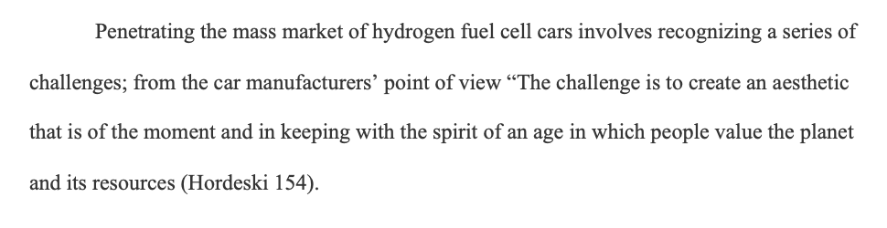
Figure 1 Two-Part Citation Process: In-Text Citation

Example of Corresponding Works Cited
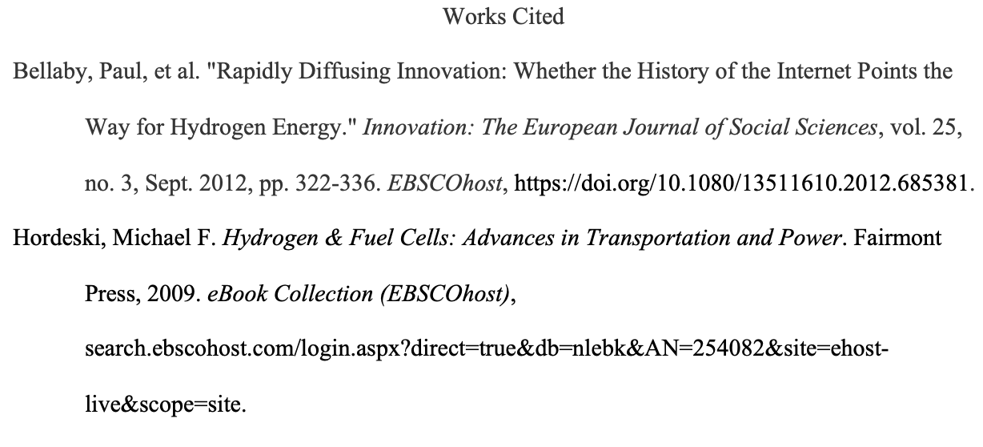
Figure 2 Two-Part Citation Process: Works Cited

Part 1: Documenting your sources within your paper

What is an In-text Citation?
An in-text citation (parenthetical citation) involves referencing the works of others within your text. A parenthetical citation is the method that requires placing relevant source information in parentheses after a quote, a paraphrase, or a summary. An in-text citation should include the author’s last name and the page number, or other location marker like time stamp (i.e.: the range of hours, minutes and seconds for film and podcasts) in parentheses. However, if the author has already been introduced in a short introductory statement (citation in prose) leading to a quote, paraphrase, or summary, give the author’s full name at first mention and the last name alone in subsequent citations in prose, and enclose the page number or other location marker in parentheses.

Example of a Short Quotation
Quoting a source means you are stating what someone else has written, word for word, using the author’s own words. Enclose the quotation within quotation marks. Provide the author and specific page citation in the text and include a complete entry on the Works Cited page.
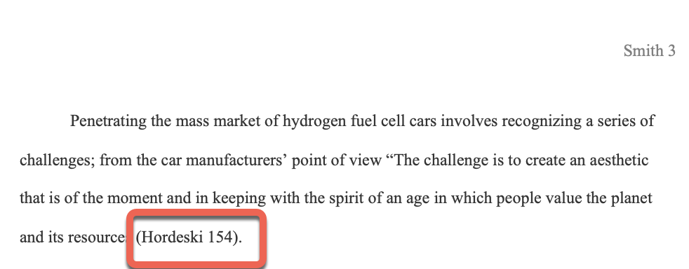
Figure 3 Short Quotation: Parenthetical Citation
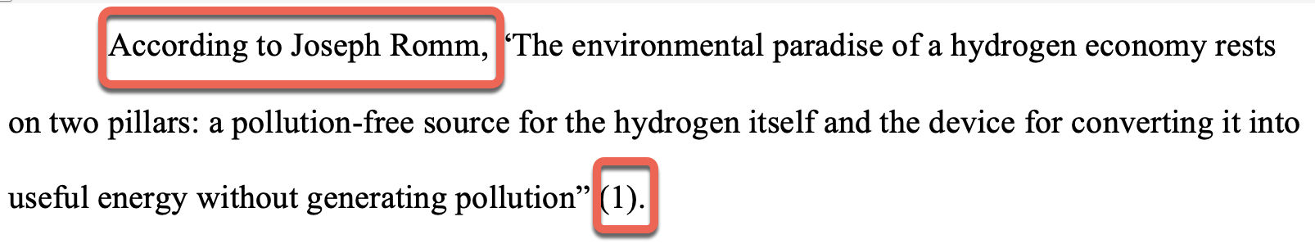
Figure 4 Short Quotation: Citation in Prose

Example of a Long Quotation
When a quotation is longer than four lines of text, place the direct quotation in a freestanding block of text without quotation marks. Start the quotation on a new line, with the entire quote indented 1⁄2 inch from the left margin; maintain double spacing. After the closing punctuation mark, provide the author and page number (or page number only if the author has already been introduced) in parenthesis. Include a complete reference on the Works Cited page.
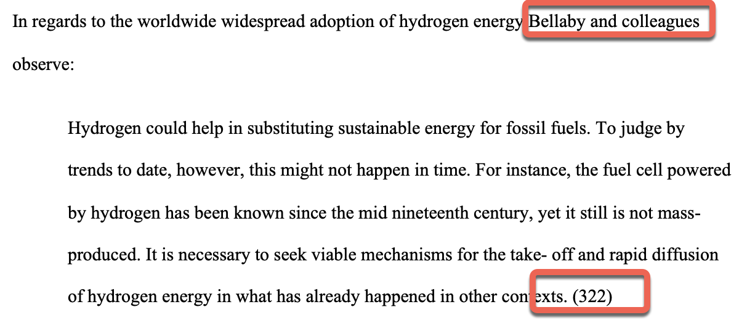
Figure 5 Long Quotation

Example of a Paraphrase
To paraphrase is to put someone else’s ideas in your own words. Summarizing involves using your own words to draw out the main argument(s) of the original work (a novel, article, film, etc.), but reducing its length. When paraphrasing, you still need to include a complete citation entry on the Works Cited page.
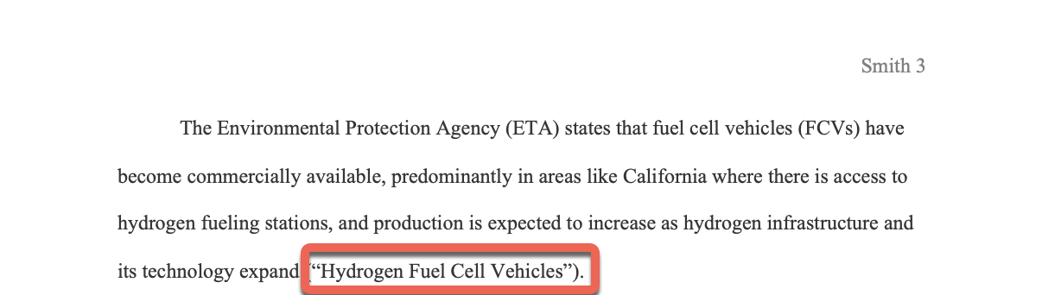
Figure 6 Paraphrase
If the author is the same organization that published the source as in the above example, use the source title in your in-text citation. If the source title is long, provide a brief version of the title in your in-text citation and give the full title in the citation on your Works Cited page. Many web sources lack page numbers. Treat the source as unpaginated.

In-text Citations & Citation Entries: Required Elements & Style

Citing a Work by One Author
In a parenthetical citation, use the author’s last name only and page number, if available. Punctuation marks such as periods, commas, and semicolons go outside the parentheses.
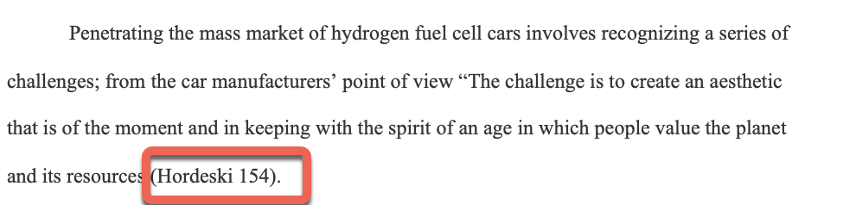
Figure 7 Work by One Author. Parenthetical Citation
In a citation in prose, give the author’s full name at first mention and the last name alone in subsequent citations; enclose the page number or other location marker in parentheses, if available. The period goes outside the brackets.
Figure 8 Work by One Author. Citation in Prose
Figure 9 Work by One Author. Citation in Prose
The citation entry on the Works Cited page should begin by having the author in last name, first name format.
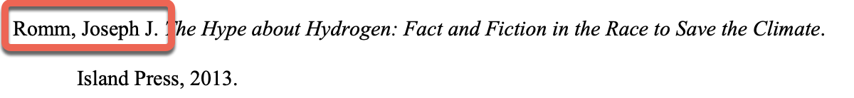
Figure 10 Work Cited. One Author

Citing a Work by Two Authors
In a parenthetical citation, include both last names and connect them with the conjunction and. Provide the page number or page number range.
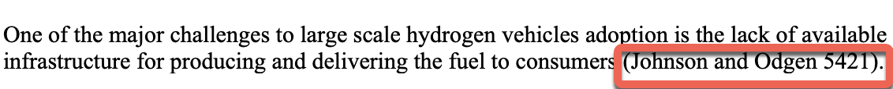
Figure 11 Work by Two Authors. Parenthetical Citation
In a citation in prose, give the authors’ full names at first mention and their last names alone in subsequent citations; enclose the page number in parentheses.
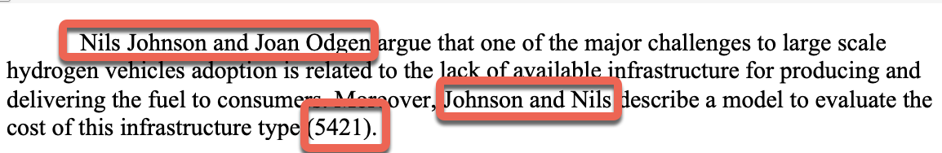
Figure 12 Work by Two Authors. Citation in Prose
The citation entry on the Works Cited page should begin by having the first author that appears on the source in last name, first name format while the coauthor in first name last name format. A comma is needed right before the conjunction and to easily distinguish the two names:
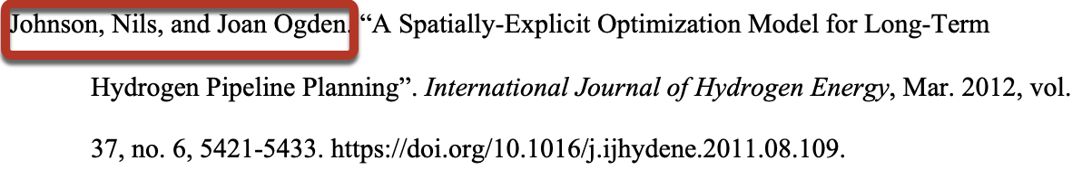
Figure 13 Work Cited. Two Authors

Citing a Work by Three or More Authors
In a parenthetical citation, include the last name of the first author and replace the additional names with et al.
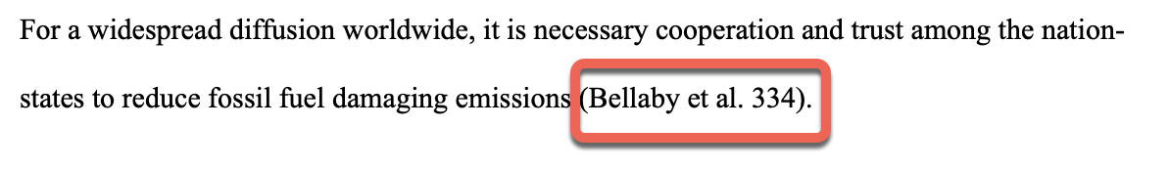
Figure 14 Parenthetical Citation. Three or More Authors
In a citation in prose, you may include all the names or the name of the first collaborator mentioned followed by the phrase “and others” or “and colleagues”.
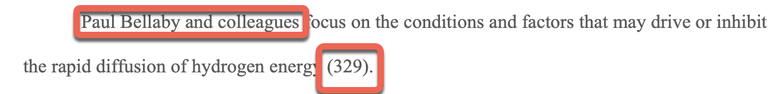
Figure 15 Citation in Prose. Three or More Authors
In the Works Cited list, begin the entry with the first author’s name in last name, first name format followed by et al.
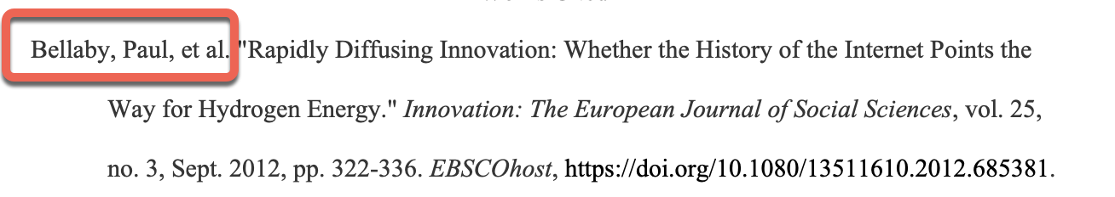
Figure 16 Work Cited. Three or More Authors

Part 2: Creating a Works Cited Page

How do I create a citation?
To create a Works Cited entry consider the following core elements:
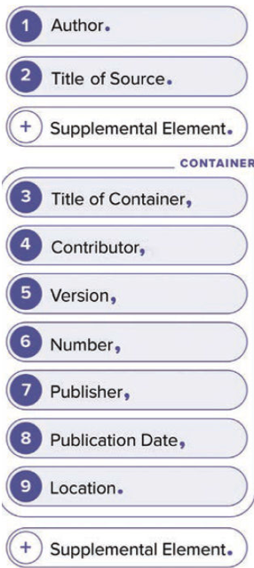
Figure 17 The MLA Template of Core Elements.MLA Stlye Center.
These elements are presented in the order in which they should appear; each element is also followed by the required punctuation mark (either a comma or a period). Omit any element that is not available except Title of Source, for which you should provide a brief description as the title.
An Author is the main creator of a work. Give the name of the author, editor or compiler when they are the primary responsible for the work followed by the descriptive label.
An author’s name is written in Last Name, First Name format, followed by their middle name or initial. This rule does not apply to organizations, government agencies and stage names or pseudonyms that lack a last name. For sources with two authors, give the first author in last name, first name format and the co-author in first name, last name format (see Figure 13). For sources with three or more authors, begin the citation entry with the first author’s name in last name, first name format followed by et al. (see Figure 16). If no author is available, start with the title.
Example of a work by one editor:
Suib, Steven L., editor. Batteries, Hydrogen Storage and Fuel Cells. Elsevier, 2013.
The Title of Source is a word, phrase, or sentence naming the work. List the title of the work as it is found in the source. If the work has no title, provide a concise description as the title. Titles are italicized for independent or self-contained works such as an entire book, a website, an album, and a TV series. If the title is part of a larger source like an article in a magazine, a poem in an anthology, a song in an album, a video in a website, use quotation marks. Capitalize all major words except prepositions and conjunctions, unless they are the first word of a title or follow a colon.
Example of a self-contained work (entire print book):
Romm, Joseph J. The Hype about Hydrogen: Fact and Fiction in the Race to Save the Climate. Island Press, 2013.
Example of a source that is part of a larger work (chapter of an eBook):
Bron, Michael, and Christina Roth. “Fuel Cell Catalysis from a Materials Perspective.” Batteries, Hydrogen Storage and Fuel, edited by Steven L. Suib, Elsevier, 2013, pp. 271-305. eBook Collection (EBSCOhost), search.ebscohostcom/login.aspx?direct=true&db=e000xna&AN=485208&site=ehost-live&scope=site.
Title of Container: A container is a work that houses another work. Some sources may have several containers, such as an article published in a journal (container 1) which is contained in a database (container 2), or an episode of a TV series (container 1) that is available through a streaming platform (container 2). The title of the container should be italicized.
Example of a work with one container (a film in a streaming database):
“The Green Economy: Hydrogen Fuel.” Film Ideas, 2014. Kanopy. 2014, coastline.kanopy.com/video/green-economy-hydrogen-fuel.
Example of a work with two containers (an article published in a journal retrieved in a database):
Bellaby, Paul, et al. "Rapidly Diffusing Innovation: Whether the History of the Internet Points the Way for Hydrogen Energy." Innovation: The European Journal of Social Sciences, vol. 25, no. 3, Sept. 2012, pp. 322-336. EBSCOhost, https://doi.org/10.1080/13511610.2012.685381.
Contributors are people, groups, or organizations that are not the primary creators but whose role is relevant to the work. Key contributors may include: editors, translators, illustrators, film directors, audiobook narrators, and performers. You may introduce each name in First Name and Last name order by describing the role played (adapted by, directed by, introduction by, narrated by, etc.).
Example of a work with more than one editor as contributors (an article in an edited book):
Atkins, William Arthur. "Fuel Cells." Energy: In Context, edited by Brenda Wilmoth Lerner, et al., vol. 1, Gale, 2016, pp. 355-359. Gale eBooks, link.gale.com/apps/doc/CX3627100098/GVRL?u=coastlinecc&sid=bookmark-GVRL&xid=acb3a9bc.
Example of a work where a newspaper is responsible for uploading a video to a sharing site: (a video in YouTube):
“Hydrogen: Fuel of the Future?” YouTube, uploaded by The Economist, 25 Aug. 2021, youtube.com/watch?v=fkX-H24Chfw.
A Version: is a variation in which the source has been released. For books or video games it may be a numbered or named edition, for a film it may be a director’s cut. Provide this element in ordinal numbers, without superscript (3rd.). Abbreviate the terms revised and edition (rev. and ed.). E-Book versions of a printed book can be included as a version provided there is no URL (i.e. when software is needed on a personal electronic device.)
Example of a republished work (book with edition number):
Holbrook, J. Britt, editor. Ethics, Science, Technology, and Engineering: A Global Resource, 2nd ed., Macmillan Reference USA, 2015. 4 vols. Gale eBooks, link.gale.com/apps/pub/4PCU/GVRL?u=coastlinecc&sid=bookmark-GVRL.
Number: A source may be part of a sequence like a numbered volume of an encyclopedia, a journal that publishes issues, or a tv show with numbered episodes or seasons. Some sources include more than one number, if these are available, give both components along with the appropriate level. Common examples include the abbreviations vol. and no. for volume and issue, and the labels season and episode preceding the numbers. Use arabic numerals.
Example of a multivolume work (reference work):
Holbrook, J. Britt, editor. Ethics, Science, Technology, and Engineering: A Global Resource, 2nd ed., Macmillan Reference USA, 2015. 4 vols. Gale eBooks, link.gale.com/apps/pub/4PCU/GVRL?u=coastlinecc&sid=bookmark-GVRL.
Example of a work with volume and issue number (magazine article):
Bullis, Kevin. "Forget Hydrogen Cars and Buy a Hybrid." MIT Technology Review, vol. 118, no. 2. Mar.-Apr. 2015, p. 20. ProQuest, search-proquest-com.ezproxy.ccclib. nocccd.edu/docview/1677666797?accountid=40745.
The Publisher: is the entity that makes the work available for distribution to the public. They include: organizations, institutions government agencies or departments, film or tv studios, networks. List the publisher’s name including its punctuation as presented in the source. Leave out business terms such as Publishing or Publisher, Pictures, Corp. Ltd., Co. Use the abbreviation UP if the publisher is a university press (Oxford UP, State U of New York P). However, if the term University is not part of the publisher’s name and the word Press appears, spell Press (MIT Press). You may omit a publisher for ongoing publications such as journals and newspapers, self-published works, and websites that make works available but do not publish them (YouTube, JSTOR).
Example of a work published by a university press:
Fay, James A., and Daniel S. Golomb. Energy and the Environment: Scientific and Technological Principles. Oxford UP, 2012.
The Publication Date is the date when the version of the work was produced. This element may be the date of composition for unpublished materials such as letters, the date of revision or upload for websites, the label forthcoming for works that are going to be published, or the date on which a source was viewed (a play). The date may include: a year, a day and month, a season, a range of years. Include the most specific date found in the source. Use the date-month-year format; abbreviate month names longer than four letters using the three letters followed by a period except for May, June and July (19 Mar. 2020). Lowercase seasons for the year (fall 2009).
Example of a publication date for a webpage:
“Hydrogen Fuel Cell Vehicles.” Green Vehicle Guide, Environmental Protection Agency, 05 Dec. 2017, www.epa.gov/greenvehicles/hydrogen-fuel-cell-vehicles.
The Location depends on the work format; for paginated works that are contained in another work like journal, magazine, and news articles, and book chapters provide a page number range (i.e., first and last page number listed at the beginning and end of the article or chapter); for unique works such as a performance, lecture, or artwork the location where the work was viewed.
For online sources it is also necessary to include the DOI, permalink or URL. If a DOI is not preceded by http:// or https://, precede the DOI number with the following label: https://doi.org/ Doing so will allow your reader to view the source in a browser window. If a DOI is not available, provide the permalink; otherwise use the URL. URLs can be truncated by omitting the http:// or https://
Example of a paginated journal article with DOI:
Bellaby, Paul, et al. "Rapidly Diffusing Innovation: Whether the History of the Internet Points the Way for Hydrogen Energy." Innovation: The European Journal of Social Sciences, vol. 25, no. 3, Sept. 2012, pp. 322-336. EBSCOhost, https://doi.org/10.1080/13511610.2012.685381.
The Supplemental Elements refer to the additional information or description that defines the work. This additional information may be included right after the Title of the Source or, if it pertains to the source as a whole, at the end of your citation entry. More than one item of information may be present. List them and separate them by commas. A period should be placed after a given supplemental element.
Supplemental elements placed after the Title of the Source may include:
- Contributors other than authors (editors, interviewers, translators, illustrators, etc.). Introduce each name in First Name and Last Name order by describing the role played.
- Date of original publication: provide the work’s original date when important to provide insights into the work’s creation or relation to other works (for archival materials such as letters or films, musical compositions and songs).
- Generically labeled section of a work like an introduction, preface, foreword that also has a unique title. You may provide this unique title as well as the generic label as supplemental information; however, generally speaking, generic title can be omitted.
Some common elements of Supplemental elements placed at the End of an Entry; include:
- Access date for online works when a publication date is not available.
- Publication medium when there two or various media options at the same location, such as in an audio/video recording and a transcript or file type like a PDF. You may include indicators such as Transcript; Transcript of lyrics, and PDF download. You may also identify other formats such as lectures.
- Series name and number for book series can be placed at the end of the citation to refer to the entire source.
Example of a source that was accessed via its transcript (video):
“The Green Economy: Hydrogen Fuel.” Film Ideas, 2014. Kanopy. 2014, coastline.kanopy.com/video/green-economy-hydrogen-fuel. Transcript.

Common Sources: Core Elements of Citations:

Journal Article: Identifying its core elements
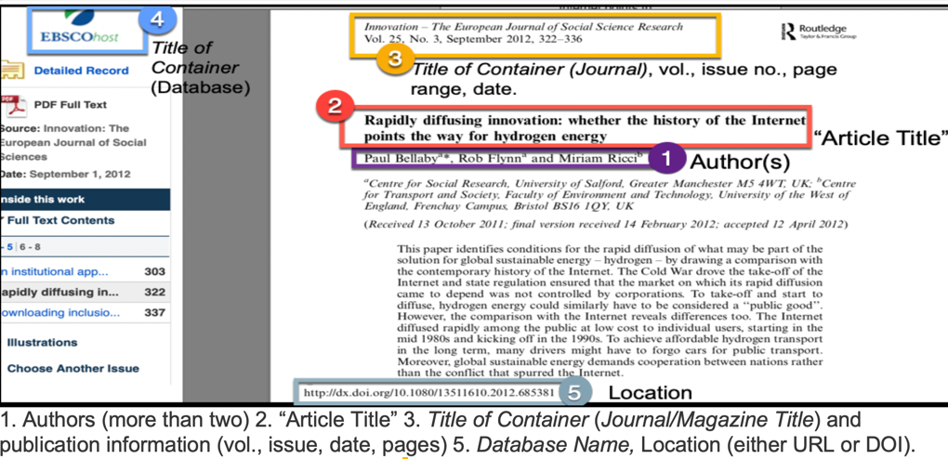
Figure 18: Journal Article

Journal Article: Formatted citation
Bellaby, Paul, et al. "Rapidly Diffusing Innovation: Whether the History of the Internet Points the Way for Hydrogen Energy." Innovation: The European Journal of Social Sciences, vol. 25, no. 3, Sept. 2012, pp. 322-336. EBSCOhost, doi:10.1080/13511610.2012.685381.

Webpage: Identifying its core elements
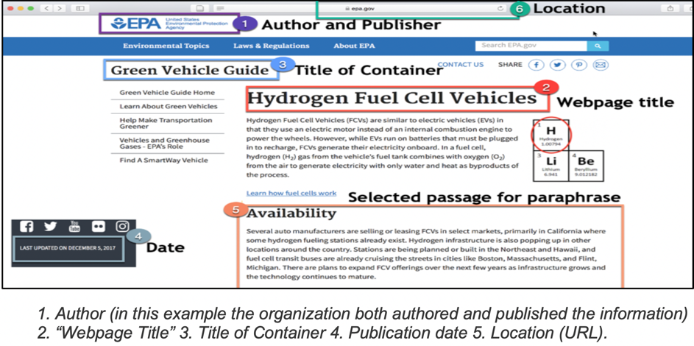
Figure 19: Government Source

Webpage: Formatted citation
“Hydrogen Fuel Cell Vehicles.” Green Vehicle Guide, Environmental Protection Agency, 5 Dec. 2017, www.epa.gov/greenvehicles/hydrogen-fuel-cell-vehicles.

eBook: Identifying its core elements
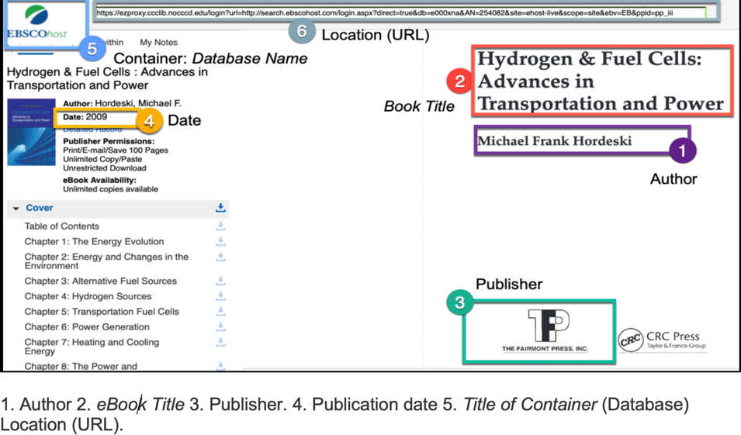
Figure 20: eBook

eBook: Formatted citation
Hordeski, Michael F. Hydrogen & Fuel Cells: Advances in Transportation and Power. Fairmont Press, 2009. eBook Collection (EBSCOhost), search.ebscohost.com/login.aspx?direct=true&db=nlebk&AN=254082&site=ehost-live&scope=site.

Works Cited List Guidelines
The Works Cited page should appear on a new page at the end of your paper. Label this page Works Cited (or Work Cited if only one source was used). Center this title at the top of the page (do not bold, underline or italicize the title). Each cited source must appear on this list. All citation entries should be doubled-spaced and organized by the author's last name in alphabetical (A-Z) order. The first line of a citation entry should be flushed to the left margin while the second and the subsequent lines should have a 0.5 inch hanging indent from the left margin.

To double-space, you can use your word-processing program as follows:
- Highlight the citations or text
- Go to the Home tab and find the Paragraph section
- Display the drop-down menu of the Line-spacing
- Choose 2.0
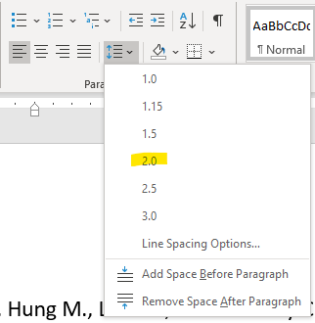
Figure 11 Line Spacing
To create the hanging indent, use the paragraph-formatting option:
- Highlight the entire citation with your cursor and right click
- Select the option paragraph
- Under the option Indentation, select Special and Hanging (Don’t add space between paragraphs of the same style)
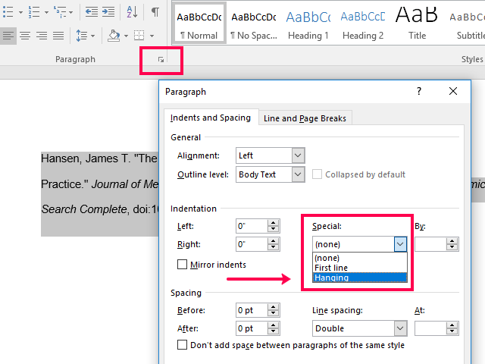
Figure 12 Hanging Indentation

Works Cited Page Example
The works cited page example shown below includes all citation entries for the sources used for the in-text citations. For a citation example of a journal article, see the entries for Bellaby and Johnson; for an example of a magazine article, see Bullis; for print and electronic books, see Romm and Hordeski respectively; for an example of an electronic book chapter see Bron; for a film see the entry under: “The Green Economy”; and for a webpage, see the entry “Hydrogen Fuel Cell Vehicles”.
Works Cited
Bellaby, Paul, et al. "Rapidly Diffusing Innovation: Whether the History of the Internet Points the Way for Hydrogen Energy." Innovation: The European Journal of Social Sciences, vol. 25, no. 3, Sept. 2012, pp. 322-336. EBSCOhost, https://doi.org/10.1080/13511610.2012.685381.
Bron, Michael, and Christina Roth. “Fuel Cell Catalysis from a Materials Perspective.” Batteries, Hydrogen Storage and Fuel, edited by Steven L. Suib, Elsevier, 2013, pp. 271-305. eBook Collection (EBSCOhost), search.ebscohostcom/login.aspx?direct=true&db=e000xna&AN=485208&site=ehost-live&scope=site.
Bullis, Kevin. "Forget Hydrogen Cars and Buy a Hybrid." MIT Technology Review, vol. 118, no. 2. Mar.-Apr. 2015, p. 20. ProQuest, search-proquest-com.ezproxy.ccclib. nocccd.edu/docview/1677666797?accountid=40745.
“The Green Economy: Hydrogen Fuel.” Film Ideas, 2014. Kanopy. 2014, coastline.kanopy.com/video/green-economy-hydrogen-fuel.
Hordeski, Michael F. Hydrogen & Fuel Cells: Advances in Transportation and Power. Fairmont Press, 2009. eBook Collection (EBSCOhost), search.ebscohost.com/login.aspx?direct=true&db=nlebk&AN=254082&site=ehost-live&scope=site.
“Hydrogen Fuel Cell Vehicles.” Green Vehicle Guide, Environmental Protection Agency, 5 Dec. 2017, www.epa.gov/greenvehicles/hydrogen-fuel-cell-vehicles.
Johnson, Nils, and Joan Ogden. “A Spatially-Explicit Optimization Model for Long-Term Hydrogen Pipeline Planning”. International Journal of Hydrogen Energy, Mar. 2012, vol. 37, no. 6, 5421-5433. https://doi.org/10.1016/j.ijhydene.2011.08.109.
Romm, Joseph J. The Hype about Hydrogen: Fact and Fiction in the Race to Save the Climate. Island Press, 2013.

