Coastline Community College Online Library

APA 7 Citation Basics

At the end of this worksheet, students will be able to
- Acknowledge the contributions of others
- Establish credibility for their own work
- Direct readers to source materials
- Apply basic knowledge of how to create and format APA citations and a Reference list

Why do I need a citation?
- Citations are a way to credit the work of others who have made your own research possible
- Citations allow your readers to find your source material
- Citations allow your readers to examine your topic by further reading
- Citations help establish the credibility of your own research

What is a citation?
A citation is a written reference to a specific work such as a book, report, article, or music score produced by a creator (a particular author, editor, or composer). APA style is used primarily in the social sciences. APA style requires acknowledgement of a source within the text of a paper along with a corresponding entry on the References page, located at the end of a document.

Example of an In-text Citation
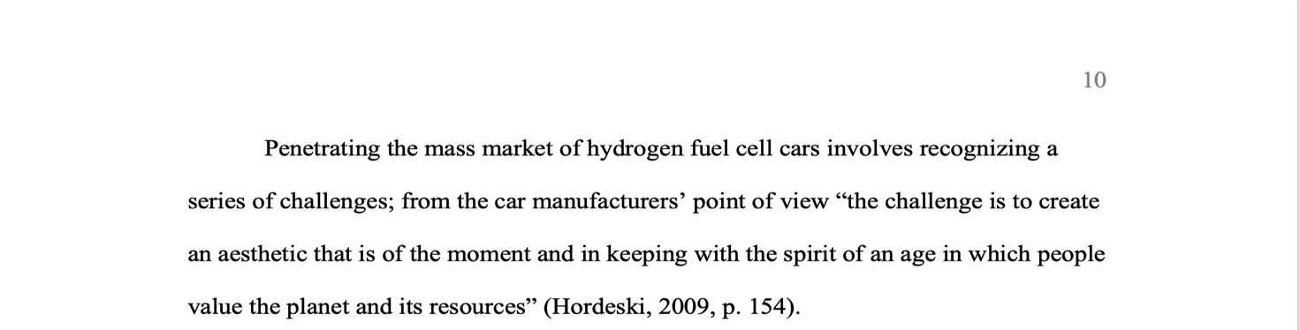
Figure 1 Two-Part Citation Process: In-Text Citation Example

Example of Corresponding References page
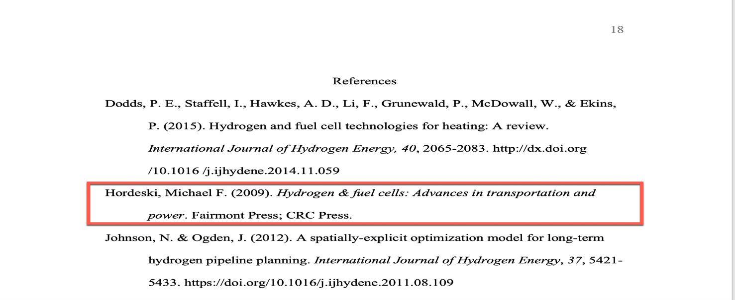
Figure 2 Two-Part Citation Process: References Page Example

Part 1: Documenting your sources within your paper

What is an In-text Citation?
An in-text citation involves referencing the works of others in your text. There are two types of in-text citations: parenthetical and narrative. A parenthetical citation is the method that requires placing relevant source information within parentheses after a quote, or a paraphrase. However, if the author has already been introduced via a short introductory statement, just enclose the date in parentheses. APA style uses the author–date citation system. All in-text citations should include: author and date; although some in-text citations, like quotations, also require a page number from the cited source.

Quotations
Quoting a source means you are stating what someone else has written word for word, using the author’s own words. Enclose the quotation within double quotation marks. Provide the author’s last name (or the first author’s last name and et al. in the case of a work by three or more authors), year and specific page number in the text. If the date of publication is not available, put the n.d. abbreviation for no date in parentheses in place of the date. Include a complete reference entry on the Reference list.

Example of a Short Quotation
Enclose within double quotation marks quotes comprising fewer than 40 words. If the author and year are part of the narrative, enclose page number in parentheses, or, you may cite the source in parentheses right after the quotation marks. Place a period or other punctuation outside the final parentheses.

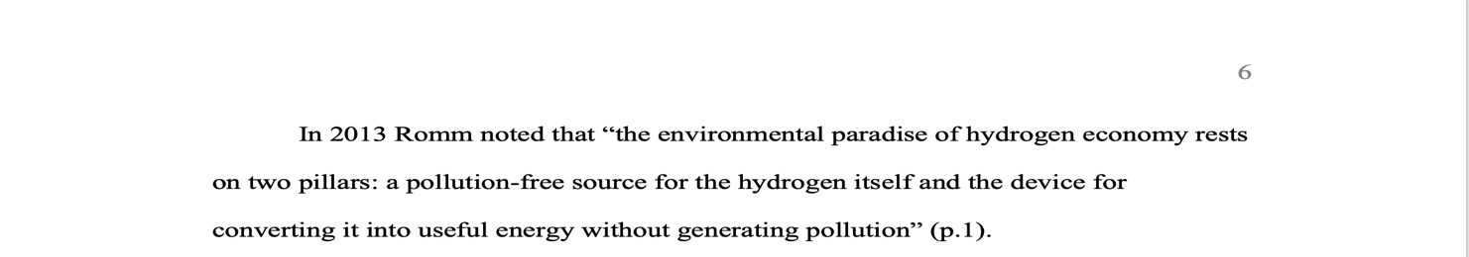
Figure 3 Short Quotation: Narrative Citation
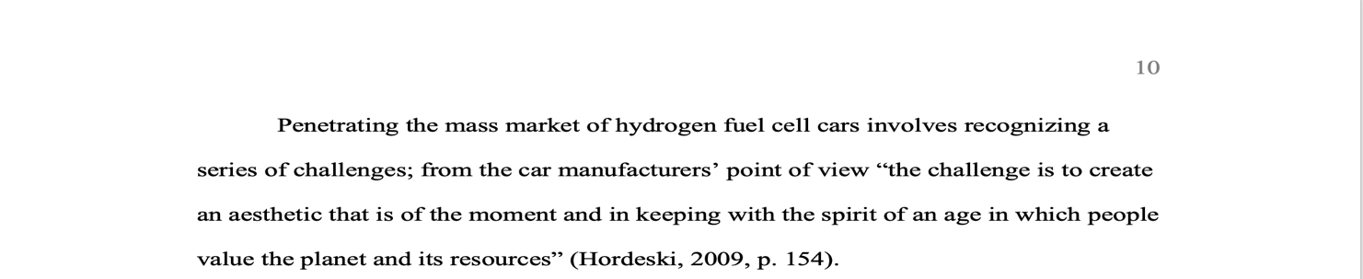
Figure 4 Short Quotation: Parenthetical Citation

Example of a Long Quotation
For quotations of 40 or more words, place the quotation in a freestanding block of text without quotation marks. Start the quotation on a new line. The entire quote should be indented ½ inch from the left margin and double-spaced. If the author and the year of publication have already been introduced in the narrative provide the page number preceded by the abbreviation p. or pp. between parentheses (narrative citation). Otherwise, provide the source (i.e., author, date, and page number) between parentheses after the quotation’s final punctuation (parenthetical citation). Do not include a period after the parentheses in either case.

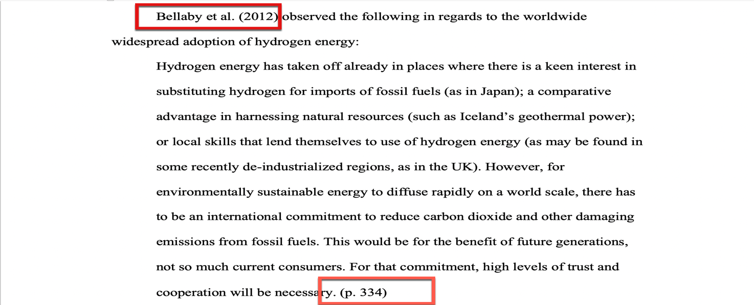
Figure 5 Long Quotation: Narrative Citation
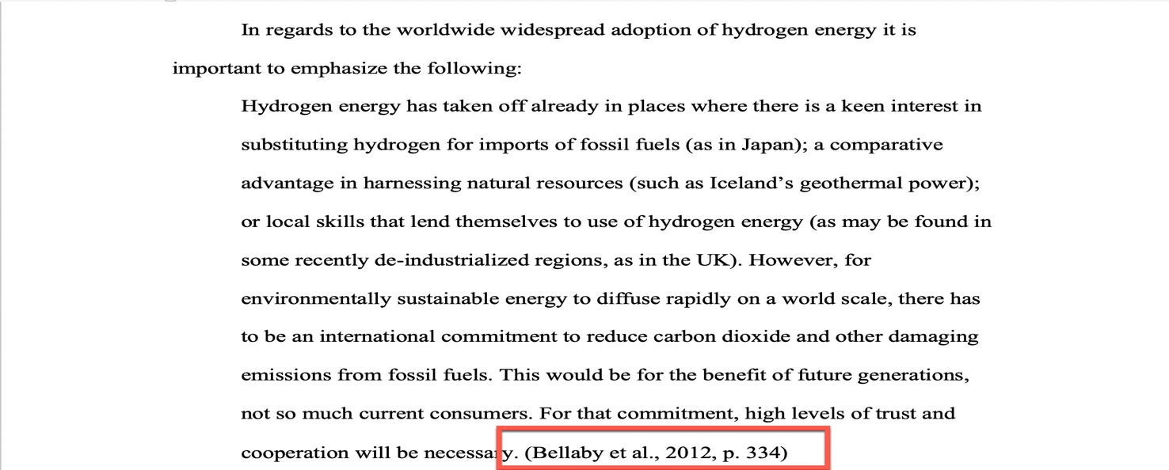
Figure 6 Long Quotation: Parenthetical Citation

Paraphrase
To paraphrase is to put someone else’s ideas in your own words. This strategy allows you to summarize and synthetize information from one or more sources.

Example of a Paraphrase
When paraphrasing an idea from another work, provide the author’s name and year of publication. For works with no date use the n.d. abbreviation. Even though it does not require a page or paragraph number, APA encourages the inclusion of this information if this helps the reader locate the cited passage in a long text. Include a complete reference entry on the Reference list; for this entry omit the site name if the author and the site are the same.

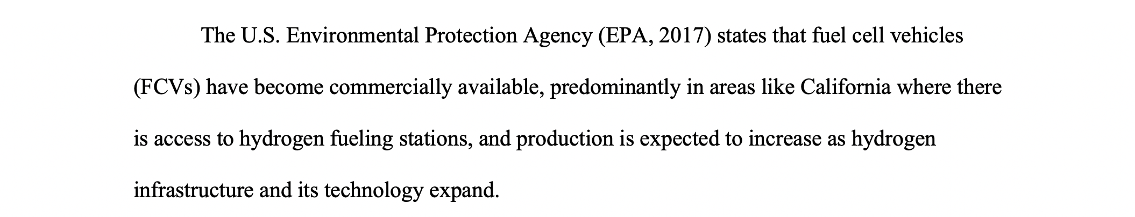
Figure 7 Paraphrase: Group Author with Abbreviation

Citing a Source by Two Authors
When quoting or paraphrasing a source with two authors, give both authors’ last names in the narrative citation or in parentheses each time the work is mentioned. Use the word "and" between the authors' names in the narrative and the ampersand (&) if the authors are part of a parenthetical citation and reference entry.

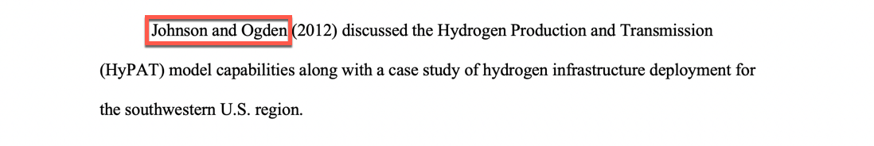
Figure 8 Example of a Source with Two Authors (Narrative Citation)
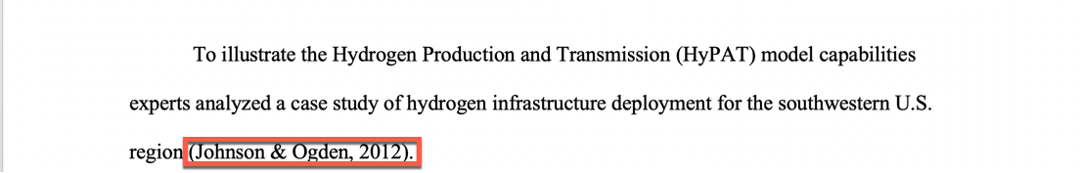
Figure 9 Example of a Source with Two Authors (Parenthetical Citation)

Citing a Source by Three or More Authors
For an in-text citation of works by three or more authors, only provide the first author followed by et al. For the reference list entries, include the first 20 authors by last names along with their initials, and use an ampersand (&) before the last author name.

Figure 10 Example of a Source by Six Authors (Narrative Citation)

Figure 11 Example of a Source by Six Authors (Parenthetical Citation)
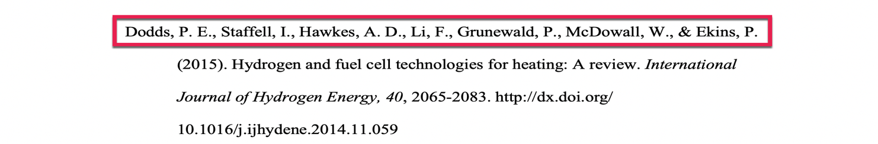
Figure 12 Reference Entry. Source by Six Authors

Citing a Source by Twenty-One or More Authors
When there are twenty-one or more authors, give only the first author followed by et al. for an in-text citation as shown in the above example. For the reference list entries include the first nineteen authors’ last names, followed by their initials, and insert an ellipsis (three dots, each preceded by a space . . . ) with no ampersand, and provide the final author’s name in the reference entry.

Figure 13 Reference entry. Source with Twenty-Three Authors

Citing a Source by a Group, Organization as an Author
If the author is an organization or a government agency that has a well-known abbreviation, include the abbreviation in parentheses the first time the source is cited and then use only the abbreviation in later citations. For the reference entry give the full name of the group.

When the group appears first in a narrative citation: include the abbreviation before the year in parentheses, separated with a comma.

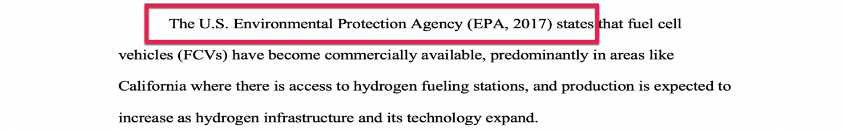
Figure 14 Example of a Source with a Group Author (Narrative Citation)

But if the group name appears first mentioned in a parenthetical citation, include the abbreviation in square brackets, followed by a comma and the year.

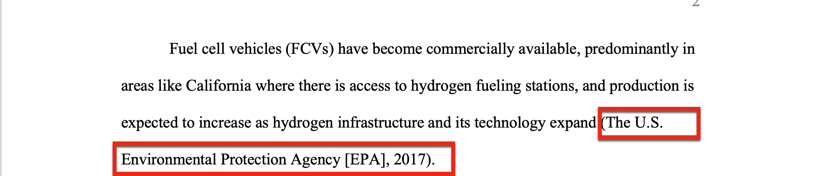
Figure 15 Example of a Source with a Group Author (Parenthetical Citation)

Part 2: Creating a Reference List

How do I create a citation?
Below are the core elements required for a reference entry for three common source types. These core elements are presented in the order in which they should appear; each element is also followed by the required punctuation mark. When available, use all of the information required to create reference citations.

Common Sources: Core Elements of Citations:

eBook: Identifying its core elements
A Source by a Single Author:

Author, A. A. (Year of publication). Title of book: Subtitle. Publisher Name. DOI or URL

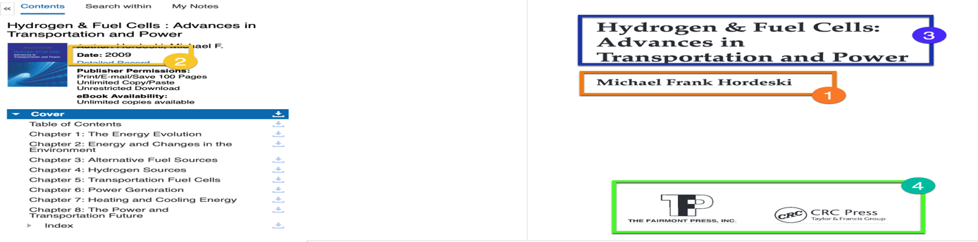
Figure 16: eBook. Core Elements of a Citation

eBook without DOI from an academic database: Formatted citation:

Hordeski, M. F. (2009). Hydrogen & fuel cells: Advances in transportation and power. Fairmont Press; CRC Press.

Webpage: Identifying its core elements
A Source by a Group Author:

Author, A. A. (Year of publication). Title of page. Site name. URL

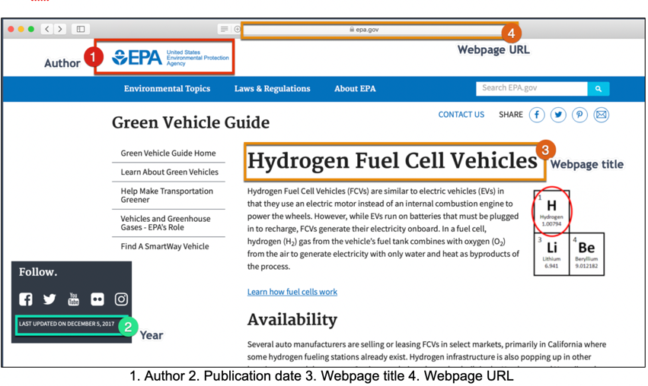
Figure 17: Webpage: Core Elements of a Citation

Webpage: Formatted citation

U.S. Environmental Protection Agency. (2017, December 5). Hydrogen fuel cell vehicles. https://www.epa.gov/greenvehicles/hydrogen-fuel-cell-vehicles

Journal Article: Identifying its core elements
A Source by Three to Twenty Authors:

Author, A. A., Author, B. B., & Author, C. C. (Year of publication). Article title. Title of Periodical, volume(issue), pages. DOI

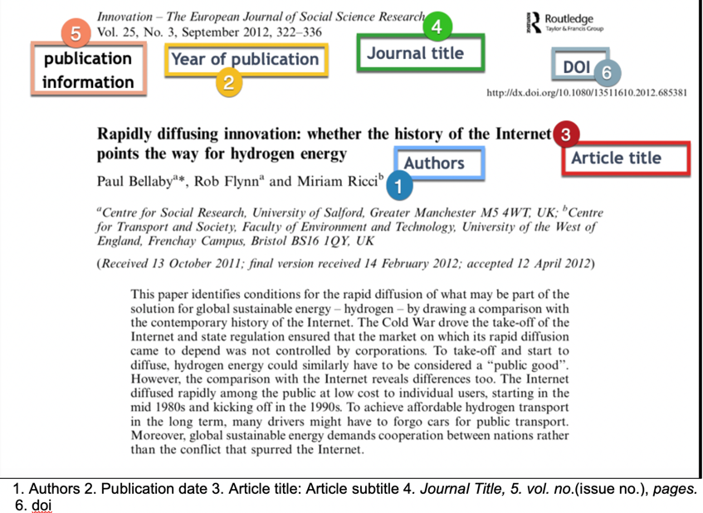

Figure 18: Journal Article: Core Elements of a Citation

Journal Article: Formatted citation

Bellaby, P., Flynn, R., & Ricci, M. (2012, September). Rapidly diffusing innovation: Whether the history of the internet points the way for hydrogen energy. Innovation: The European Journal of Social Sciences, 25(3), 322-336. https://doi.org/10.1080/13511610.2012.68538

Reference List Guidelines
The reference list should appear at the end of your paper on a new page and before any appendices. Label the reference list References (or Reference if only one source was used). Provide this title in bold and centered at the top of the page.

Each source cited must appear in this list. All citation entries should be doubled-spaced and organized by the author's last name in alphabetical (A-Z) order.

The first line of a citation entry should be flushed to the left margin while the second and the subsequent lines should have a 0.5 inch hanging indent from the left margin.
To double-space, you can use your word-processing program as follows:
- Highlight the citations or text
- Go to the Home tab and find the Paragraph section
- Display the drop-down menu of the Line-spacing
- Choose 2.0

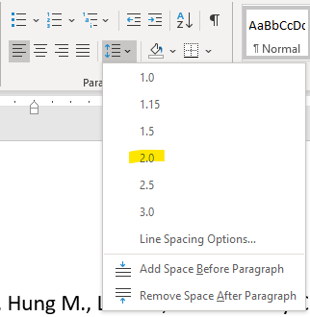
Figure 19 Line Spacing
To create the hanging indent, use the paragraph-formatting option:
- Highlight the entire citation with your cursor and right click
- Select the option paragraph
- Under the option Indentation, select Special and Hanging (Don’t add space between paragraphs of the same style)

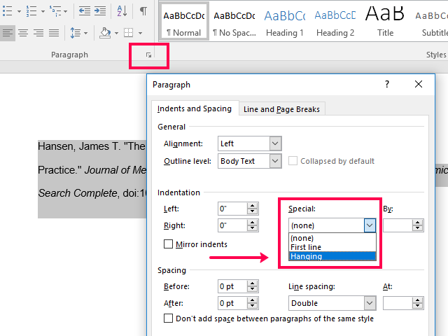
Figure 20 Hanging Indentation

Reference List Example
The reference list example shown below includes all citation entries for the sources used in this handout. For journal article citation examples, see the following entries: Bellaby, Dodds, Johnson, Robertson. For a magazine article citation example see Ball, for book citation examples see Hordeski and Romm, and lastly, for a website citation example see the entry for the US Environmental Protection Agency.
References
Ball, J. (2015, February). Facing the truth about climate change. New Republic, 246(1), 24–29.
Bellaby, P., Flynn, R., & Ricci, M. (2012). Rapidly diffusing innovation: Whether the history of the internet points the way for hydrogen energy. Innovation: The European Journal of Social Sciences, 25(3), 322-336. https://doi.org/10.1080/13511610.2012. 685381
Dodds, P. E., Staffell, I., Hawkes, A. D., Li, F., Grunewald, P., McDowall, W., & Ekins, P. (2015). Hydrogen and fuel cell technologies for heating: A review. International Journal of Hydrogen Energy, 40, 2065-2083. http://dx.doi.org/10.1016/j.ijhydene.2014.11.059
Hordeski, M. F. (2009). Hydrogen & fuel cells: Advances in transportation and power. Fairmont Press; CRC Press.
Johnson, N. & Ogden, J. (2012). A spatially-explicit optimization model for long-term hydrogen pipeline planning. International Journal of Hydrogen Energy, 37, 5421-5433. https://doi.org/10.1016/j.ijhydene.2011.08.109
Robertson, G.P., Dale, V. H., Doering, O. C., Hamburg, S. P., Melillo, J. M., Wander, M., Parton, W. J., Adler, P. R, Barney, J. N., Cruse, R. M., Duke, C. S., Fearnside, P. M., Follett, R.F., Gibbs, H. K., Goldemberg, J., Mladenoff, D. J., Ojima, D., Palmer, M. W., Sharpley, A., . . . Wilhelm, W. W. (2008). Agriculture: Sustainable biofuels redux. Science, 322(5898), 49-50. https://doi.org/10.1126/ science.1161525
Romm, J. J. (2013). The hype about hydrogen: Fact and fiction in the face to save the climate. Island Press.
U. S. Environmental Protection Agency. (2017, December 5). Hydrogen fuel cell vehicles. https://www.epa.gov/greenvehicles/hydrogen-fuel-cell-vehicles

